**BARRIERS TO EV ADOPTION**

**Unsafe**

People are finding technology involving batteries to be unsafe. The primary safety among the people is most probably the nature of battery to explode during an accident or due to extreme weather conditions causing fire. The most common type of battery used in EV is lithium ion battery which has tendency to explode if punctured or damaged.

**Lack of Trust in Technology**

As the technology is emerging in electric vehicle people have lack of trust due to several significant reasons. The technology is still not considered ready for daily usage such as autonomous driving. Manufacturing companies feel that electric vehicles are vulnerable to hacking and loss of control. People believe this loss of control over their vehicle could allow major technology companies to have higher control over their action and also can lead to expose their personal data.

**Unreliability**

People are doubtful about the battery and its degradation with time. This degradation could farther lead to a drop in the performance and range of the vehicle implying they cannot use the vehicle the same way they used it when the East Asian Journal of Multidisciplinary Research (EAJMR) Vol. 1, No. 7, 2022: 1303-1316 1305 vehicle was new. Apart from that customers find particularly challenging as the charging infrastructure is different across location adding many cases of unreliable. The charging points could turn out to be out of order forcing to detour the passengers if they are in a hurry.

**Range**

Range refers to the distance that electric vehicle can travel in one single charge or battery. Range is very dependent on size and condition of the battery with degradation of battery range can also decrease. Range is also dependent on the driving style of the driver and can never be comparable to conventional ice engines. In India EV only on aprox gives 300 to 400 kms on a single charge. So it’s quite obvious that of a family with an EV cannot travel long distances.

**Repair**

Repairing and working on electric vehicle feels like ant repair mentality and people are more dependent on servicing centers which makes a lot of profit as there have the permission to repair electric vehicle. Repairing and on traditional vehicles is identified to be very popular and repairing cars on their own provides them a sense of satisfaction and is hobby for many. They prefer buying cars which can be repair avoiding dependency on service center.

**Bad Looks and Futuristic Concept**

Most people think that electric vehicles are ugly. They believe that all electric vehicles pose a similar design language which is not very desirable. They find this language to be wacky and cheap. They find this desire language to be hard effort to look futuristic. They feel it lacks the overall presence unimaginative.

**Lack of Fun**

People believe that electric vehicles are boring and not fun compared to ICE technology. They lack depth in experience like lack gear shifting, makes people less engaged while driving. They state that this feeling is further due to lack of manual transmission which is not possible in electric vehicle. They question the ignorance of fun and every vehicle should be fun to drive and own.

**Cost of Purchase and Ownership**

The most popular and frequently mentioned theme through the data was the cost of purchase involved with electric vehicles. It is worth noting that average cost of EV is higher than petrol vehicles. Majority of the user mentioned that cost involved in the purchase of EV is their barrier to adoption. They believe Manjula, Shilpa, Sundaresh 1306 the technology is overpriced and highly taxed considering the specification and build quality of the vehicles. Data also states that electric vehicles are also expensive to maintain and repair unlike normal vehicle and hence they insurance cost is also high.

**Lack of Infrastructure**

Lack of infrastructure in our country is also pushing customers back from purchasing electric vehicles. There are no adequate charging stations in all the major cities and locations which again stopping its development. Due to no battery manufacturing facility in the nation is making its difficult to manufacture our own vehicles and develop own companies in the nation.

**Lack of Awareness** There is no proper program to make everyone aware of its uses and how it helps in our daily life. It does not reach out to rural areas where literacy is very less and also very difficult for them to understand its importance and how it improves the society. Due to lack of awareness of its benefits and also its part and role in improving our environment and society also slowing the pace of its development in the nation.

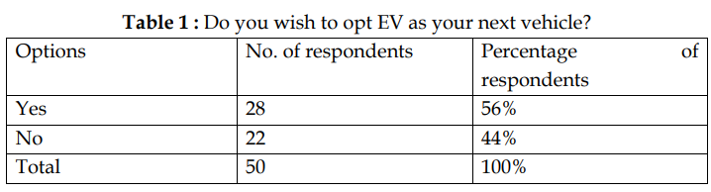

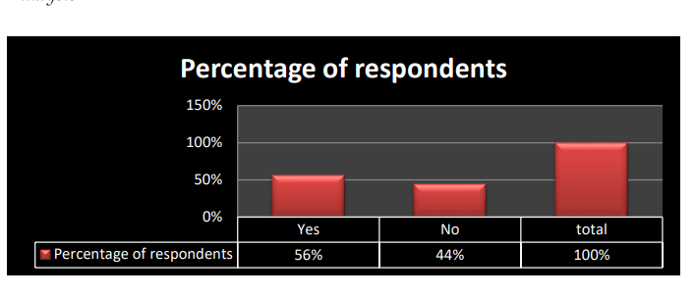

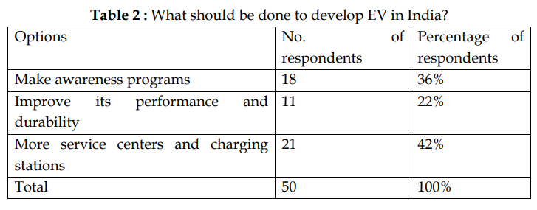

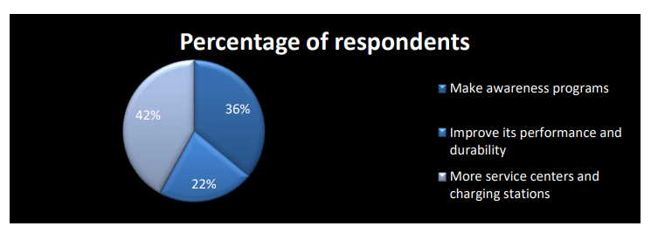

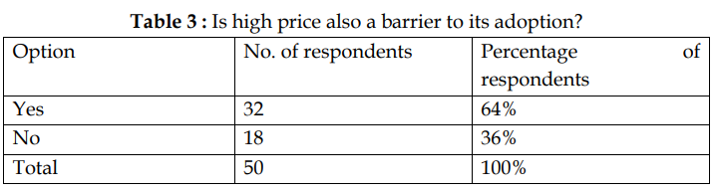

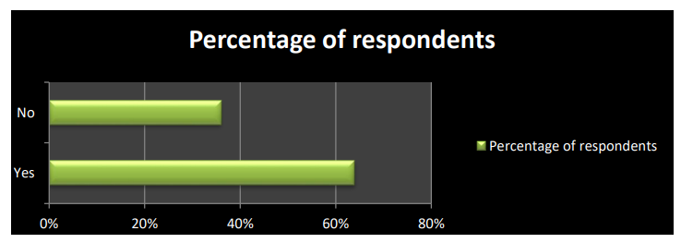

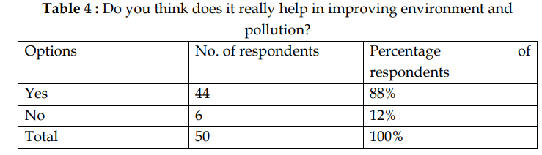

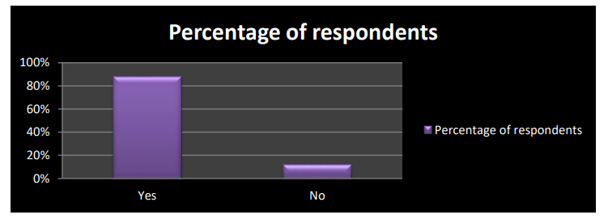

**BENEFITS OF EVs**

**Lower running costs**

The running cost of an electric vehicle is much lower than an equivalent petrol or diesel vehicle. Electric vehicles use electricity to charge their batteries instead of using fossil fuels like petrol or diesel. Electric vehicles are more efficient, and that combined with the electricity cost means that charging an electric vehicle is cheaper than filling petrol or diesel for your travel requirements. Using renewable energy sources can make the use of electric vehicles more eco-friendly. The electricity cost can be reduced further if charging is done with the help of renewable energy sources installed at home, such as solar panels.

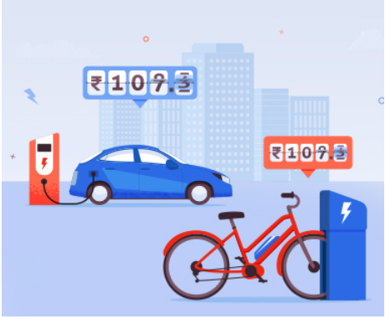

**Low maintenance cost**

Electric vehicles have very low maintenance costs because they don’t have as many moving parts as an internal combustion vehicle. The servicing requirements for electric vehicles are lesser than the conventional petrol or diesel vehicles. Therefore, the yearly cost of running an electric vehicle is significantly low.

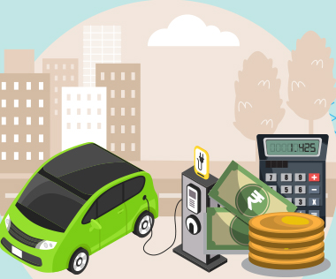

**Zero Tailpipe Emissions**

Driving an electric vehicle can help you reduce your carbon footprint because there will be zero tailpipe emissions. You can reduce the environmental impact of charging your vehicle further by choosing renewable energy options for home electricity.

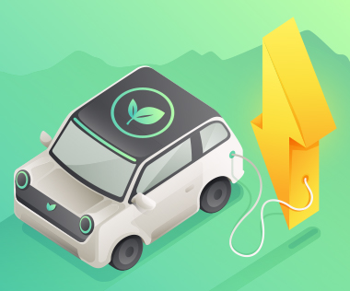

**Tax and financial benefits**

Registration fees and road tax on purchasing electric vehicles are lesser than petrol or diesel vehicles. There are multiple policies and incentives offered by the government depending on which state you are in. To find out more about electric vehicle incentives, click below .

[ELECTRIC VEHICLE INCENTIVE](https://e-amrit.niti.gov.in/electric-vehicle-incentives)

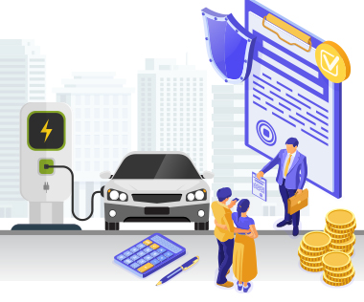

**Petrol and diesel use is destroying our planet**

The availability of fossil fuels is limited, and their use is destroying our planet. Toxic emissions from petrol and diesel vehicles lead to long-term, adverse effects on public health. The emissions impact of electric vehicles is much lower than petrol or diesel vehicles. From an efficiency perspective, electric vehicles can covert around 60% of the electrical energy from the grid to power the wheels, but petrol or diesel cars can only convert 17%-21% of the energy stored in the fuel to the wheels. That is a waste of around 80%. Fully electric vehicles have zero tailpipe emissions, but even when electricity production is taken into account, petrol or diesel vehicles emit almost 3 times more carbon dioxide than the average EV. To reduce the impact of charging electric vehicles, India is ambitious to achieve about 40 percent cumulative electric power installed capacity from non-fossil fuel-based energy resources by the year 2030. Therefore, electric vehicles are the way forward for Indian transport, and we must switch to them now.

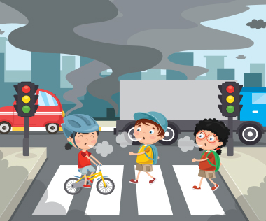

**Electric Vehicles are easy to drive and quiet**

Electric vehicles don’t have gears and are very convenient to drive. There are no complicated controls, just accelerate, brake, and steer. When you want to charge your vehicle, just plug it in to a home or public charger. Electric vehicles are also quiet, so they reduce noise pollution that traditional vehicles contribute to.

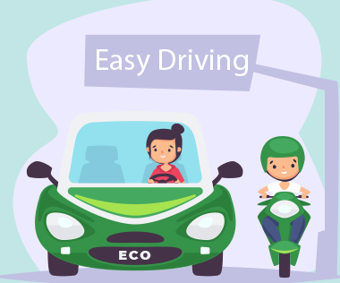

**Convenience of charging at home**

Imagine being at a busy fuel station during peak hours, and you are getting late to reach your workplace. These problems can easily be overcome with an electric vehicle. Simply plug your vehicle in at your home charger for 4-5 hours before you plan to go. If you are able to get a charger where you park at home, it is very convenient to plan your journeys in advance. What if you forget to plug in your machine someday? Then you can easily take the help of fast chargers or even battery swapping services if you are on a two-wheeler on the road.

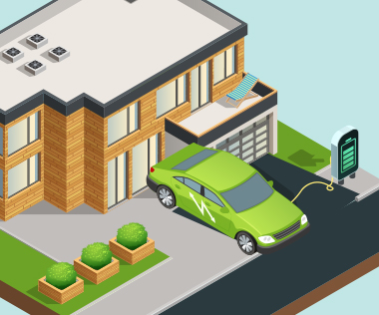

**No noise pollution**

Electric vehicles have the silent functioning capability as there is no engine under the hood. No engine means no noise. The electric motor functions so silently that you need to peek into your instrument panel to check if it is ON. Electric vehicles are so silent that manufacturers have to add false sounds in order to make them safe for pedestrians.



**EXPLOSION OF LITHIUM ION BATTRIES**

According to news agency *Reuters*, lithium-ion batteries, whether used in electric vehicles or electronic devices, are prone to [catch fire](https://www.indiatimes.com/trending/social-relevance/ola-electric-scooter-catches-fire-in-pune-565442.html) if they have been improperly manufactured or damaged or if the software that operates the battery is not designed properly.

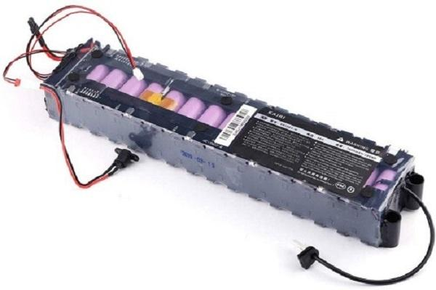

**What are batteries made of?**

First of all, let's understand what a battery is made of - cells, and these cells are just like an object which is filled with a particular form of energy. Now, since energy can neither be created or destroyed, however, it can convert its form.

The energy is stored in the form of electricity (movement of ions) in a [battery](https://www.indiatimes.com/trending/wtf/electric-scooters-battery-explodes-550559.html), which race between two oppositely charged electrodes separated by a "separator".

Now, there are types of batteries - lead-acid and lithium-ion batteries. The only difference between the two of them is their energy density. When one ion of li-ion battery transfers from anode to cathode or cathode to anode, it carries almost thrice the energy than the lead-acid battery.

An electric scooter/vehicle has enough capacity (amount of energy stored) so that it can run a complete house with its power for three to four days without any problem. An EV battery contains a lot of energy which is enough to cause damage to the vehicle operator or people nearby.

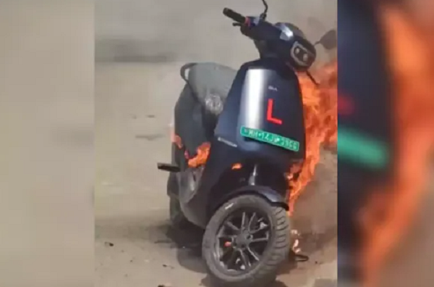YouTube

**How do batteries catch fire?**

The first thing to understand is that an explosion or fire doesn't necessarily need a lot of energy. What it takes is the least time frame to release every small amount of energy stored inside.

If a Li-ion battery stores 1kWh of storage capacity, it will be self-sufficient for combustion if all of that 1kWh releases in a matter of seconds. Every battery has an anode, cathode, and a separator in common, So, if an explosion happens, it is because of these three components only. The separator which separates the other two - anode and cathode - lets their ions transfer only, breaks or damage and then, the shortcircuit takes place which leads to an explosion.

With EV batteries, the primary cause of explosion of batteries is their separator. The main purpose of the separator is to keep the material of both anode and cathode away but continue the transfer of ions. However, due to market demand and advancement in technology, the separator has been made thinner and more thinner.

Despite separators lasting for very long, in such situations, even a single problem with the battery can lead to permanent damage. Since the separator is delicate in nature, it malfunctions due to any external pressure or internal chemical imbalance. While charging, batteries expand a little, and when discharged, they compress which further creates pressure on the separator, and it may fail to function properly. If the separator fails the moment the anode and cathode make contact, it leads to a shortcircuit which further leads to an explosion.

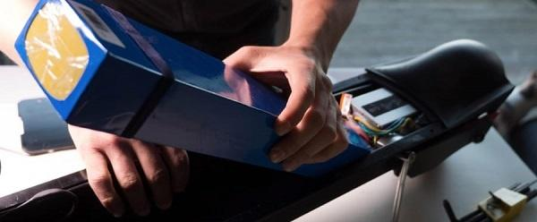Ride on Toys

So, basically, the failure of the separator is the main cause of battery failure and explosion. But what causes the damage of the separator in the first place?

**How does a battery separator get damaged?**

There are two reasons why battery separators get damaged - electrical instability and external shocks which can damage a thin separator.

Electrical instability happens when they battery is charged or discharged more than the rated capacity. With rechargeable batteries, there is are two ratings - undervoltage and overvoltage. However, if the battery exceeds either of the two ratings while charging, the separator gets damaged.

The other reason, external shock, happens when the battery falls from a certain height, stretch or buries. External shocks may not cause potential damage to the battery immediately. However, after a certain time, it will either explode or cause serious damage.

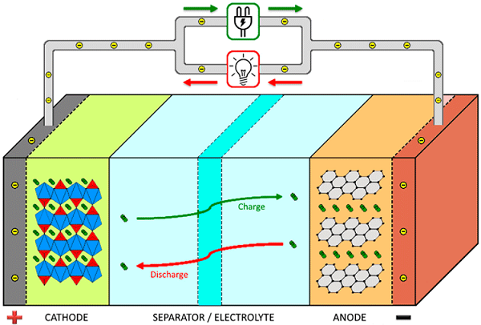Components101

**When will a battery explode?**

Internal electrical misbalance is when an electric vehicle goes through deep discharge or overcharging cycles more often. This leads to an explosion.

While overcharging, the battery gets heated up, and the thing separator gets majorly impacted by the heat energy which directly damages the separator and ends in an explosion.

During deep discharging, the anodic and cathodic reactions create crystal-like material around the separator. When the battery is allowed to charge till the same capacity it creates, the more heat is produced inside the battery which damages the separator.

Since the battery separator is highly volatile to external shocks, an electric vehicle accident will surely result in an explosion because it is usually is extremely thin and can’t resist any shocks.

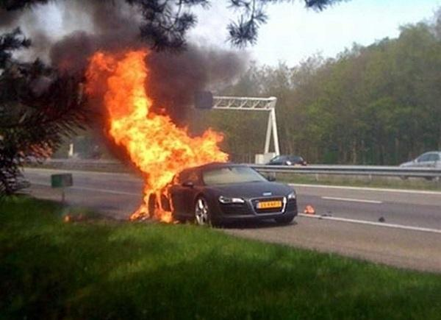Inside EVs

**What Makes a Lithium-Ion Battery Explode?**

The very thing that makes lithium-ion batteries so useful is what also gives them the capacity to catch fire or explode. Lithium is really great at storing energy. When it’s released as a trickle, it powers your phone all day. When it’s released all in one go, the battery can explode.

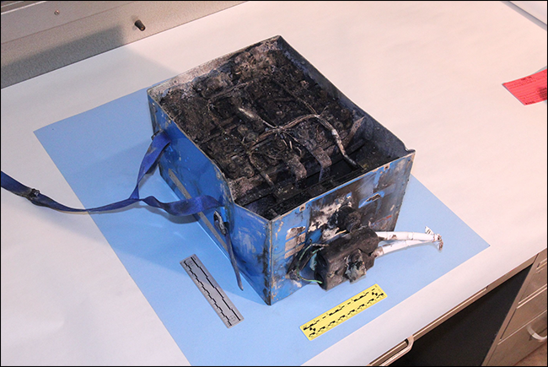This lithium-ion battery from a Japan Airlines Boeing 787 caught fire in 2013.

Most lithium-ion battery fires and explosions come down to a problem of short circuiting. This happens when the plastic separator fails and lets the anode and cathode touch. And once those two get together, the battery starts to overheat.

There are a number of reasons that the separator can fail:

* **Bad Design or Manufacturing Defects:** The battery is poorly designed, [as with the Galaxy Note 7](https://www.cnet.com/news/galaxy-note-7-explosions-caused-by-aggressive-design/). In that case, there wasn’t enough space for the electrodes and separator in the battery. In some models, when the battery expanded a little as it charged, the electrodes bent and caused a short circuit. Even a well designed battery can fail if quality control isn’t kept tight enough or there’s some defect in manufacturing.
* **External Factors:** Extreme heat is nearly guaranteed to cause a failure. Batteries left too close to a heat source—or caught in a fire—have been known to explode. Other external factor can cause a lithium-ion battery to fail, too. If you drop your phone too hard (or too many times), there’s a chance you’ll damage the separator and cause the electrodes to touch. If you pierce the battery (either by accident or deliberately), then you’ll almost certainly cause a short circuit.
* **Charger Problems:** A badly made or poorly insulated charger can also damage a lithium-ion battery. If the charger shorts or generates heat near the battery, it can do enough damage to cause failure. That’s why we recommend [using only official chargers](https://www.howtogeek.com/244846/what-to-do-when-your-phone-or-laptop-has-a-swollen-battery/) (or at the very least, high quality third party ones from reputable brands). Lithium-ion batteries do have built in protections to stop them overcharging. While very rare, if these safety precautions fail, overcharging is a good way to overheat a battery.
* **Thermal Runaway and Multiple Cells:** While not relevant to single cell batteries like those found in most smartphones (the iPhone X actually has two cells), only one battery cell needs to fail for the whole battery to go. Once one cell overheats, you get a domino effect called “thermal runaway.” For batteries with hundreds of cells—like those in the Tesla Model S—thermal runaway has the potential to be a really big problem.

**SOLUTIONS**

**1. Using liquid coolant around the battery**

Earlier this year, when Samsung released its Galaxy S7, a tech blog revealed a teardown that took a good look at the liquid cooling system which was employed by Samsung designers. The system used a very small amount of water that would continuously evaporate into steam and travel away from the processor (or, even better, the battery) to keep the temperature down on the graphics processing unit (GPU) and central processing unit (CPU), which will be running at high speed as they perform such tasks as fast Internet browsing or HD video playback. The steam later condenses back into water and evenly spreads the heat around.

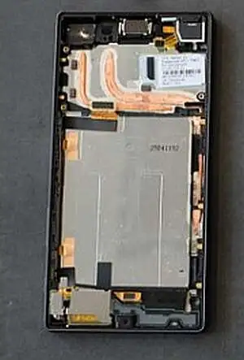

**2. Maybe coolant is not enough: Adding fire-retardant thermal insulation surrounding the battery**

Suppressing a Lithium-ion battery fire is critical when applying a coolant does not lower the battery temperature enough, especially during thermal runaway. The added step in safety might be to employ a form of [cargo foam](http://venturaaerospace.com/news/suppressing-lithium-ion-battery-fires/) which airlines use to both cool and prevent a fire from progressing and spreading. Ventura Aerospace has an excellent aircraft [fire suppression system](http://venturaaerospace.com/) used in Class E compartments which can also be creatively adapted by smartphone and laptop designers to be contained inside the battery enclosure.

**3. Added protection: strengthening the mechanical battery enclosure**

I really do not want to say much in this area because having a strong battery enclosure or surrounding case might be the last thing we really need for battery safety. I will only comment on the fact that some sort of mechanical enclosure needs to be used to possibly house the battery and any fire retardant material along with a connection to a possible cooling system. These are all mentioned in this article, so the actual case is secondary to all of the other suggestions mentioned, but nonetheless needed.

**4. Better modeling in the design and manufacturing phase6**

Pressure buildup/cell venting is deemed the most common response that is seen in Lithium-ion batteries that are subjected to abuse or poor design (**Figure**).

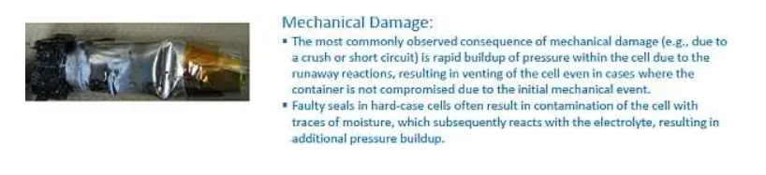

**Figure**

Mechanical damage due to a crush of short circuit is one of the many areas that can be simulated in the design and manufacturing phase with any changes tested before customers get the battery

**MARKET OPPORTUNITIES**

### ELECTRIC VEHICLES MARKET IN INDIA

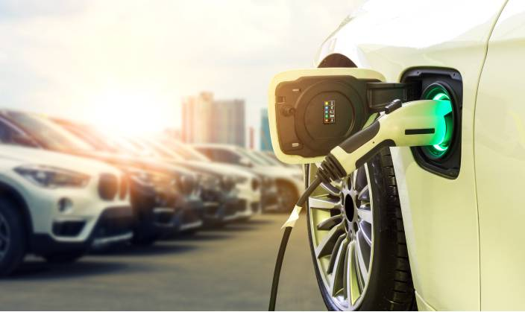

**Introduction**

The global electric vehicle (EV) market is developing at a rapid pace. According to EV volumes, overall electric vehicle reached a global share of 8.3% (including battery electric vehicles [BEVs] and Plug- in hybrid electric vehicles [PHEVs]) in 2021 from 4.2% in 2020 with 6.75 million vehicles on the road. This is an increase of 108% as of 2020. EVs are gaining attention across the globe as they help reduce emissions and depletion of natural resources. The Indian EV market is also evolving fast as close to 0.32 million vehicles were sold in 2021, up 168% YoY. Ongoing electric vehicle adoption in India is based on the Paris agreement to reduce carbon emissions, to improve the air quality in urban areas and reduce oil imports.

**Electric Vehicle Sales Trend in India (2020-21)**

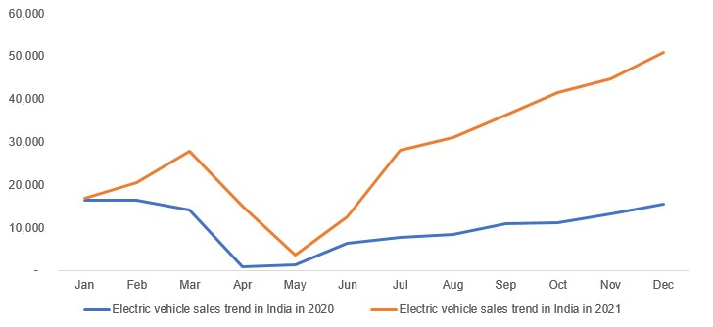  
Source: EV reporter

**EV Market in India**

The Indian automobile industry is the fifth largest in the world and is expected to become the third largest by 2030. As per India Energy Storage Alliance (IESA), the Indian EV industry is expected to expand at a CAGR of 36%. As population rises and demand for vehicles grow, dependence on conventional energy resources is not a sustainable option as India imports close to 80% of its crude oil requirements. NITI Aayog aims to achieve EV sales penetration of 70% for all commercial cars, 30% for private cars, 40% for buses and 80% for two and three-wheelers by 2030. This is in line with the goal to achieve net zero carbon emission by 2070. Over the last three years, 0.52 million EVs were registered in India, according to the Ministry of Heavy Industries. EVs recorded robust growth in 2021, supported by the implementation of favourable policies and programmes by the government.

In India, Uttar Pradesh held the highest share in EV sales in 2021, with the number of units sold across all segments reaching 66,704, followed by Karnataka with 33,302 units and Tamil Nadu with 30,036 units. Uttar Pradesh dominated the three-wheeler segment, while Karnataka and Maharashtra led the two-wheeler segment and four-wheeler segment, respectively.

**State -Wise-EV Sales Trend in 2021**

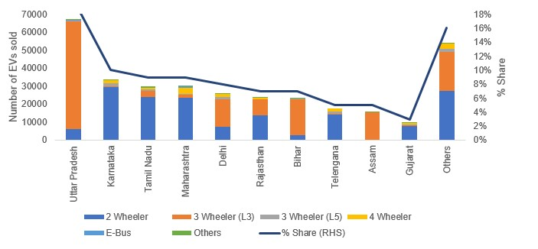  
Source: EV Reporter

Hero Electric, Okinawa and Ather Energy controls the electric two-wheeler market in India with a combined market share of 64%. Hero Electric has a market share of 36% followed by Okinawa with 21%. Ather Energy with an 11.1% market share is slowly gaining market share, as the company is currently expanding its distribution network across India. In the passenger vehicle segment, Tata Motors enjoys a commanding position in electric vehicle space with a market share of 71%, led by their two key models, Nexon and Tigor EV. MG Motors India enjoys the second position and offers the longest-range EV (MG EZS provides 439 KM range on a single charge). Other Indian manufacturers have announced their models and is expected to be launched in the future.

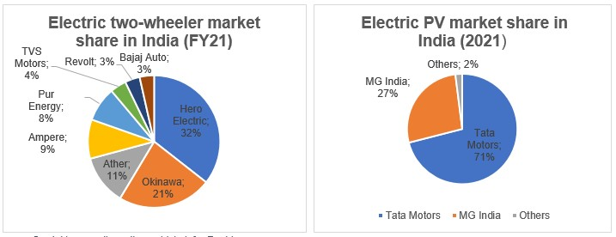  
Source- Cardekho, gaadiwaadi, e-vehicle info.,Rushlane.

**Key Policy Initiatives**

**– Growth Levers**

The Government of India has always been at the forefront of framing policies related to EV adoption in the country. Few of the programmes launched by the government to increase EV adoption are shown below:

**Business Opportunities**

The EV push in India opens a plethora of business opportunities across three key segments – mobility, infrastructure and energy. These include opportunities in EV franchising, EV OEM market, battery infrastructure, solar vehicle charging and battery swapping technology among several others. According to NITI Aayog, the complete transition to EVs requires a total investment of US$ 267 billion (Rs.19.7 lakh crore) in EVs, battery infrastructure and charging infrastructure.

According to the Ministry of Skill Development and Entrepreneurship (MSDE), the EV industry could add 10 million direct jobs by 2030 which would create 50 million indirect jobs in the sector. Several automobile companies have plans to participate in the EV industry as listed in the table below:

* **FAME India Scheme:**

Faster Adoption & Manufacturing of (Hybrid &) Electric Vehicles (FAME) India was launched in 2015 for promoting growth and early adoption of hybrid and electric vehicles in the country. FAME-II scheme was launched in India with a budget outlay of US$ 1.3 billion (Rs. 10,000 crore) to support 1 million e-two-wheelers, 0.5 million e-three -wheelers, 55,000 e-passenger vehicles and 7,000 e-buses. The government extended the scheme until 2024, as announced in Union Budget 2022-23.

* **PLI Scheme:**

Thegovernment introduced Production Linked Incentive for Advanced Chemistry Cell Battery Storage (PLI-ACC) scheme. The scheme is expected to boost India’s battery infrastructure. As per the Union Budget, the total outlay for the scheme is US$ 2.45 billion (Rs 18,100 crore), which would be disbursed to beneficiaries over five years once the manufacturing facility is set up.

* **Battery Swapping Policy:**

Awide-spread charging infrastructure is essential for EV adoption. In this regard, on April 22, 2022, NITI Aayog released a draft battery swapping policy which will be valid until March 31, 2025. The policy will be implemented over a period of 1-2 years from the date of launch of the policy and will cover all metropolitan cities with a population greater than four million. The second phase will be implemented over 2-3 years from date of launch of the policy and will cover all UT’s and major cities with a population greater than 5,00,000.

* **Other Initiatives-**

|  |  |
| --- | --- |
| **Company** | **EV related plans** |
| Kia | Kia plans to manufacture small SUV EVs in India for global markets in 2025. |
| Maruti Suzuki | Maruti Suzuki plans to launch its first EV model in India by 2025. |
| Tata Motors | Tata Motors bags an order worth US$ 678 million (Rs 5,000 crore) order from the government for electric buses; it plans to launch 10 more EVs in India. |
| Hyundai | Hyundai plans to launch IONIQ 5 EV in India by the second half of 2022. |
| Hopcharge | Hopcharge, a Gurgaon- based start-up has created the world’s first on-demand doorstep fast charge service. |
| MG Motors | MG Motors India has partnered with Bharath petroleum for expanding the EV charging infrastructure. |
| Mahindra & Mahindra | Mahindra and Mahindra targets to launch 16 EV models across its SUV and LCV categories by 2027. |

* + Tax exemption of up to Rs.1,50,000 (US$ 1,960) under section 80EEB of income tax while purchasing an EV (2W or 4W) on loan.
  + Reduction of customs duty on nickel ore (key component of lithium-ion battery) from 5% to 0%.
  + State- wise reduction of road tax and other incentives.

According to the Ministry of Skill Development and Entrepreneurship (MSDE), the EV industry could add 10 million direct jobs by 2030 which would create 50 million indirect jobs in the sector. Several automobile companies have plans to participate in the EV industry as listed in the table below:

**Conclusion**  
The Indian EV Industry is slowly gathering momentum, supported by government initiatives and rise in crude oil prices, as people look for alternative sources to reduce their monthly bills. However, a mass shift from internal combustion engine (ICE) vehicles to EVs requires expansion of infrastructure facilities, including charging stations, and vehicles that could provide a higher range (KM range with a single charge). Several initiatives taken by the government to support the manufacturing and adoption of electric vehicles in the country should help in achieving the target of a 100% EV adoption by 2030.

**SOCIO ECONOMIC FACTORS**

**Socio-economic, financial and operational factors on EV purchasing behavior**

The influence of demographic factors on EV purchasing behavior was extensive in most of the past studies. **Education** was the most important attribute proven to have a positive significant relationship with the EV preference. Similarly the **size of household** was also cited in

many studies as an important factor

Following these attributes, the **level of income** was

introduced as a strong influencing factor on EV purchasing behavior in recent studies .Consequently the role of **number of vehicles in the household** has been proved in some

research to be positively significant

Other socio-demographic attributes were generally open to discussion; for instance, some studies explored

whether older people are more interested in purchasing an EV. On the other hand, some studies have found an opposite relationship

In like manner, some studies claimed that males are more attracted to purchasing EVs

while

other studies refuted the role of male as a dominate gender in EV purchasing behavior.

The **EV purchase price** has been considered in most EV adoption studies. The results of most

of these studies revealed that the price of the EV may have less significant influence on higher income people than on others .Moreover, people with high incomes are less sensitive to fuel cost .Although most of the reviewed studies pointed out that **EV battery re-filling time and driving range** is one of the concerns when purchasing an EV

claimed that EV driving range may not significantly influence people who are willing to purchase EVs. **Availability of**

**charging stations** was one of the most important factors for purchasing an EV; most of the

studies showed that EV owners tended to buy EVs if there was a charging station near their home and workplace

Influencing psychological factors on EV purchasing behavior

Psychologically speaking, environmental concerns have been addressed in most of the past

studies as the dominate factor to purchase EVs

